
BOOKSTORE INVENTORY MANAGEMENT SYSTEM

SYSTEM DOCUMENTATION

SUBMITTED BY,

A SYSTEM DOCUMENTATION SUBMITTED IN PARTIAL FULFILMENT FOR THE AWARD OF DIPLOMA IN COMPUTER SCIENCE BY ZETECH UNIVERSITY

AUGUST 2026

DECLARATION
I Brenda Chebet do declare that this is my original work and it has never been submitted elsewhere for any academic award.
Student Name: Brenda Sign: _________________ Date: _________

Supervisor Name: _________________________ Sign: _________________ Date: __________

DEDICATION
This project is dedicated to my family for their constant support, encouragement, and understanding throughout my academic journey. Their motivation and belief in my abilities gave me the strength to complete this project successfully.
Also, this project is dedicated to all students pursuing knowledge and innovation in the field of computer science.

ABSTRACT
This project focuses on the design and development of a Bookstore Inventory Management System to improve the efficiency of managing bookstore operations. Many small bookstores rely on semi-automated record keeping, which often leads to stock inaccuracies and difficulty in tracking sales. The developed system provides a digital platform that allows the bookstore owner to manage inventory, record sales, and generate reports. The system was developed using the Flask framework with HTML, CSS, JavaScript and python for the interface and SQLite for the database. The system improves accuracy, enhances inventory control, and helps the bookstore owner make better decisions through organized and real-time information management.

DEFINITION OF KEY TERMS
Inventory Management System-A computerized system used to track, manage, and control the stock of books in a bookstore, including adding, updating, and monitoring available items.
Database-An organized collection of data stored electronically that allows easy access, management, and updating of information such as book records and sales transactions.
User Authentication-A security process that verifies the identity of a user by checking login credentials such as a username and password before granting access to the system.
Dashboard-A graphical user interface that displays key information such as total books, low stock alerts, and daily sales to help the user monitor system performance.
Sales Log- A record that keeps track of all transactions made in the bookstore, including the book sold, quantity, date, and total price.
Low Stock Alert-A system notification that warns the user when the quantity of a particular book falls below a predefined level.
Entity Relationship Diagram (ERD)- A visual representation that shows how different data entities such as users, books, and sales are related within a database.
Data Flow Diagram (DFD)-A diagram that illustrates how data moves through the system and how it is processed between different components.
Flask Framework-A lightweight web development framework in Python used to build the backend of the bookstore inventory management system.
Deployment-The process of making the system available for use by hosting it on a server so users can access it through the internet.

ABBREVIATIONS AND ACRONYMS

API – Application Programming Interface
CSS – Cascading Style Sheets
DFD – Data Flow Diagram
ERD – Entity Relationship Diagram
HTML – Hypertext Markup Language
IDE – Integrated Development Environment
IT – Information Technology
SQL – Structured Query Language
UI – User Interface
URL – Uniform Resource Locator

Table of contents

DECLARATION i
DEDICATION ii
ABSTRACT iii
DEFINITION OF KEY TERMS iv
ABBREVIATIONS AND ACRONYMS v
Table of contents vi
LIST OF FIGURES viii
LIST OF TABLES ix
1. CHAPTER ONE: PROJECT PLANNING AND ANALYSIS 1
1.1. Statement of Problem 1
1.2. Study Justification 1
1.3. System Objectives 2
1.3.1. General Objective 2
1.3.2. Specific Objectives 2
1.4. Functional Requirements 3
1.5. Breakdown of Tools & Resources to Be Used 4
1.6. Gantt chart 5
2. CHAPTER TWO: DESIGN AND MODELING 6
2.1. Introduction to Modelling 6
2.2. User Interface Models 6
2.2.1. Login page 6
2.2.2. Inventory management 7
2.2.3. Sales logs 7
2.2.4. Reports 8
2.3. Logic Models 8
2.3.1. Log in process flowchart. 8
2.3.3. Data flow diagrams 10
2.3.4. Entity relationship diagram 11
2.3.5. Use case diagram 12
2.3.6. Class diagrams 13
3. CHAPTER THREE: SYSTEM IMPLEMENTATION 14
3.1. Introduction 14
3.2. User Interface Development 14
3.2.1. Login Page Development 14
3.2.2. Dashboard 16
3.2.3. Navigation bar 18
3.2.4. Inventory 19
3.2.5. Add new book form 20
3.2.6. Sales logs 22
3.2.7. Reports 23
3.3. Logic Development 25
3.3.1. Login 25
3.3.2. Dashboard 26
3.3.3. Inventory 27
3.3.4. Sales logs and reports 29
3.4. Testing 30
3.5. Deployment 31
4. CHAPTER FOUR: CONCLUSION AND RECOMMENDATION 32
4.1. Conclusion 32
4.2. Recommendation 32
REFERENCES 33

LIST OF FIGURES
Figure 2.2.1login page 6
Figure 2.2.2 inventory management form 7
Figure 2.2.3 sales log 7
Figure 2.2.4 reporting form 8
Figure 2.3.1 login process flowchart 8
Figure 2.3.2 system flowchart 9
Figure 2.3.3 DFD 10
Figure 2.3.4 ER Diagram 11
Figure 2.3.5 use case diagram 12
Figure 2.3.6 class diagram 13
Figure 3.2.1 login page development 15
Figure 3.2.2 dashboard development 17
Figure 3.2.3 navigation bar 18
Figure 3.2.4 inventory control center 20
Figure 3.2.5 add new book 21
Figure 3.2.6 sales logs 22
Figure 3.2.7 reports 24
Figure 3.3.1 Python-based user authentication function implemented using the Flask framework 25
Figure 3.3.2 dashboard backend development 26
Figure 3.3.3 inventory backend development 28
Figure 3.3.4 sales backend development 29

LIST OF TABLES

Table 1.4.1 functional requirements 3
Table 1.6.1 project schedule breakdown 5

CHAPTER ONE: PROJECT PLANNING AND ANALYSIS

Statement of Problem
Despite the growth of the digital economy, many small and medium-sized bookstores continue to manage their internal operations using semi-automated methods, such as paper-based ledgers and fragmented spreadsheets. These traditional methods present significant operational challenges, including frequent stock inaccuracies, difficulty in tracking historical sales, and a general lack of data security (Laudon & Laudon, 2022).
In the specific bookstore under study, the absence of a centralized management system has led to critical inefficiencies. Currently, inventory tracking and sales recording are handled manually, leading to human errors and financial discrepancies. Furthermore, decision-making regarding restocking is based on administrative guesswork rather than empirical sales data. This fragmentation makes it nearly impossible for the owner to analyze trends, such as identifying best-selling titles or calculating real-time daily revenue. As the volume of inventory grows, these manual processes become unsustainable, causing operational bottlenecks and potential revenue loss. There is, therefore, a need to develop a centralized, secure internal management portal that automates inventory tracking, simplifies sales logging, and provides real-time financial analytics. Such a system is essential for improving administrative efficiency, ensuring record accuracy, and enabling evidence-based business decisions.

Study Justification
The development of this project is justified by the critical need for digital transformation within the internal operations of small and medium-sized bookstores. While the retail sector has modernized, many independent booksellers still struggle with manual record-keeping, leading to stock inconsistencies and unreliable financial reporting Rashid et al (2025). This project addresses these gaps by providing an automated, centralized platform for internal management. From a management perspective, this study is significant as it eliminates the reliance on paper-based ledger systems and unorganized spreadsheets. By implementing a secure internal portal, the bookstore owner can maintain data integrity through automated stock updates and real-time transaction logging. This reduces human error and prevents financial losses caused by unaccounted sales or stock discrepancies. Furthermore, the project is justified88 by its contribution to informed decision-making. The integration of a sales analytics dashboard allows the administrator to quickly identify top-selling titles and monitor daily revenue trends. This shifts the business from a reactive "guesswork" approach to a proactive, data-driven strategy. Ultimately, this system improves overall operational efficiency and ensures that the bookstore can scale its internal processes to meet increasing demand without increasing administrative workload.

System Objectives

General Objective
- To develop an inventory management system for a bookstore.

Specific Objectives
- To develop an inventory management module for adding, editing and deleting book records, categories and prices.
- To develop an automated sales processing mechanism that reduces stock levels and logs transactions in real-time.
- To implement a low stock alert system that automatically flags books with fewer than five items remaining.
- To integrate a search functionality for quick retrieval of book details using titles, authors or ISBN numbers.

Functional Requirements

User | User Activities | Features
Bookstore owner | - Sign up and log in | - Log in page
 | - Add, update and remove book records | - Book inventory management module
 | - Monitor stock levels and sales | - Real-time stock level monitoring
 | - Generate inventory and sales report | - Sales and inventory reporting tools
 | - Make purchasing and restocking decisions | - Low-stock and reorder alerts
 | - Manage pricing and promotions | - Pricing and promotion management
Table 1.4.1 functional requirements
+

Breakdown of Tools & Resources to Be Used
1. Software Tools
- Full-Stack Framework: Flask – lightweight Python-based web framework used to handle both front-end integration and back-end logic, including routing, API handling, and security.
- Front-End: HTML, CSS, JavaScript – used for structuring web pages, styling the interface, ensuring responsiveness, and adding interactivity.
- Database: SQLite – a file-based database system used for storing application data in a simple, portable format.
2. Development Environment
- IDE: Visual Studio Code – for writing and managing front-end and back-end code.
- Version Control: Git and GitHub – Git for local version control to track changes in the source code, while GitHub was used as a remote repository for backup, collaboration, and project management.
3. Deployment Resources
- Application Hosting: PythonAnywhere will be used to host the Flask web application and manage the SQLite database in a live environment.
- Application Structure: The front-end will be integrated and served through Flask using templates and static files within the same application.
4. Hardware Resources
- Client Devices: Desktop computers, laptops and smartphones for accessing and testing the system.
- Server Machine: Local development PC.
- Networking Devices: Internet-enabled devices for system access and updates.
5. Human Resources
- System Developer: Responsible for system design, development, testing and documentation.
- Test Users: classmates.
- Project Supervisor: Provides guidance, monitoring, and evaluation throughout the project.1.6 Project Schedule Breakdown

  - Gantt chart
 | PROJECT MILESTONES
WEEKS | Project Planning & Analysis  (System Documentation: Cover page & Chapter One) | Project Design & Modeling  (System Documentation Chapter Two) | Project Development & Testing  (System Documentation Chapter Three) | Project Deployment  (System Documentation Chapter Three) | Final Touches of System Documentation  (Preliminary Pages, Chapter Four & References) | Project Presentation
4-8 May
11-15 May
18-22 May
25-29 May
1-5 Jun
8-12 Jun
15-19 Jun
22-26 Jun
29-3 Jul
6-10 Jul
13-17 Jul
20-24 Jul
31st July
Table 1.6.1 project schedule breakdown

CHAPTER TWO: DESIGN AND MODELING

Introduction to Modelling
This chapter presents the system designs and models developed to visualize the proposed bookstore inventory management system before the actual implementation begin. The diagrams and models illustrate how the system would function, how users would interact with it and how data would flow within the system. Modeling the system prior to development help to clarify requirements, identify potential challenges early and ensure that all system components are well organized. This approach reduces development errors, improve planning and provide a clear blueprint that guides the implementation process, resulting in an efficient, reliable and a well-structured system.

User Interface Models

Login page
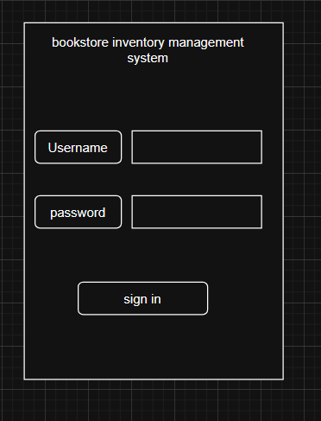
Figure 2.2.1login page

The login page illustrates a simple and secure interface where registered users enter their username and password to access the system.

Inventory management
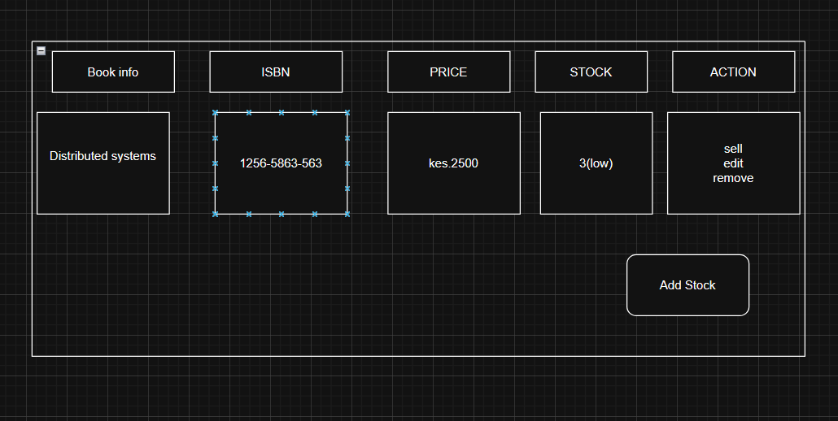
Figure 2.2.2 inventory management form
The inventory management form shows how the bookstore owner can view all books, monitor stock levels, identify low or out-of-stock items and update prices or quantities, enabling efficient stock control and timely restocking.

Sales logs
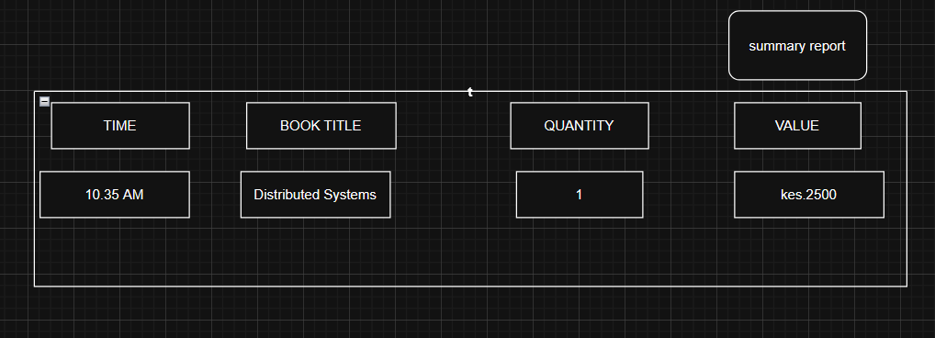
Figure 2.2.3 sales log
The sales log is a structured table for recording daily sales. It tracks the time, items sold, quantity and total price. It helps monitor sales, manage inventory, and identify fast-selling items efficiently.

Reports
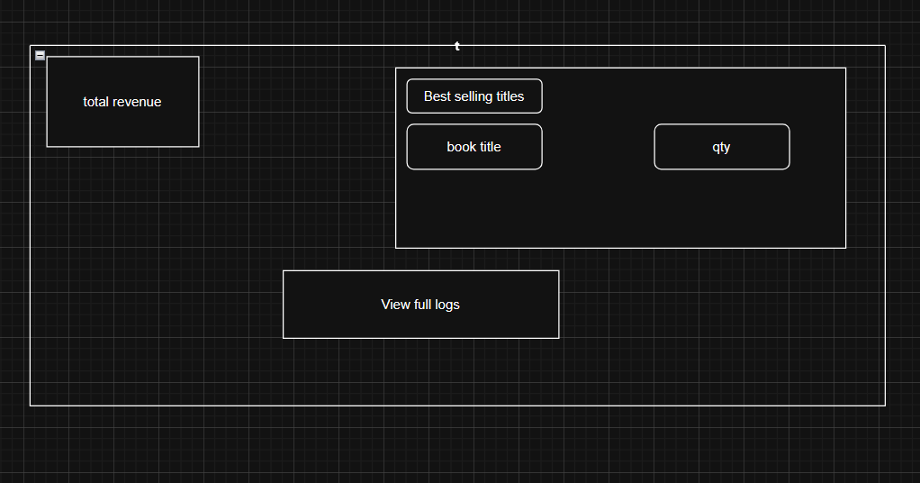
Figure 2.2.4 reporting form
The reporting form illustrates how the system generates sales, inventory and performance reports, helping the bookstore owner analyze trends, track best-selling books and make informed business decisions.

Logic Models

Log in process flowchart.
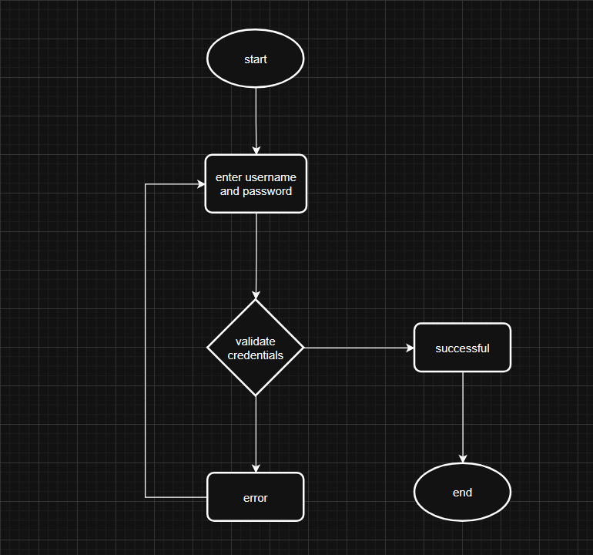
Figure 2.3.1 login process flowchart
This flowchart illustrates the steps involved when a user logs into the system. It shows how user credentials are entered, validated, authenticated and either granted access or denied based on correctness.

    - System flow chart
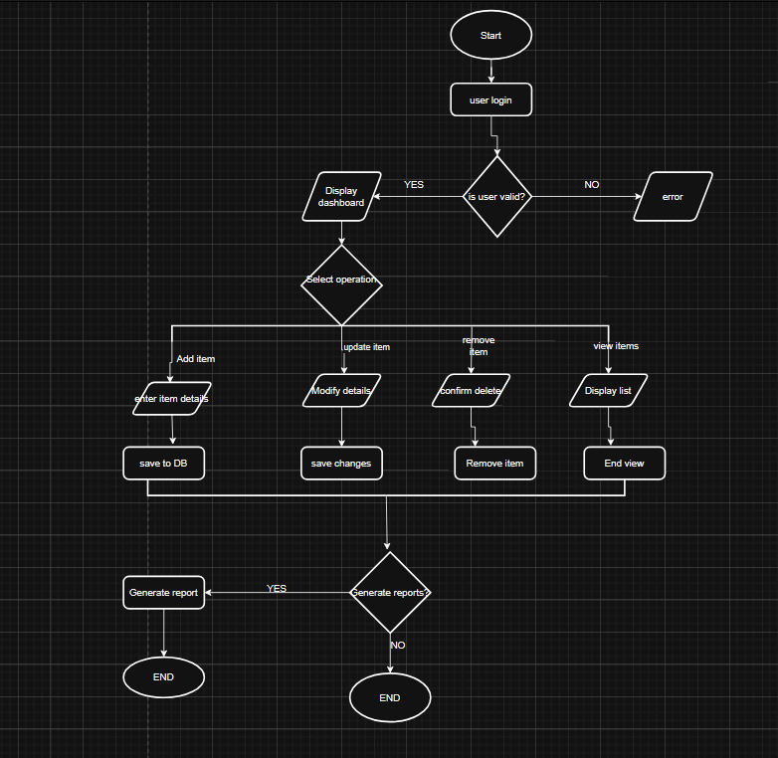
Figure 2.3.2 system flowchart

The flowchart illustrates how an inventory management system operates from start to finish. The process begins with user login, where the system verifies the user’s credentials. If the login is invalid, an error message is displayed; if valid, the user is directed to the dashboard. From there, the user selects an operation such as adding, updating, deleting, or viewing items. Each option allows interaction with the database, where item details are entered, modified, removed, or displayed accordingly. After completing these actions, the system may generate a report based on the inventory data. Finally, the process ends once the user completes their tasks. This flow ensures efficient management, accurate record keeping, and easy access to inventory information.

Data flow diagrams
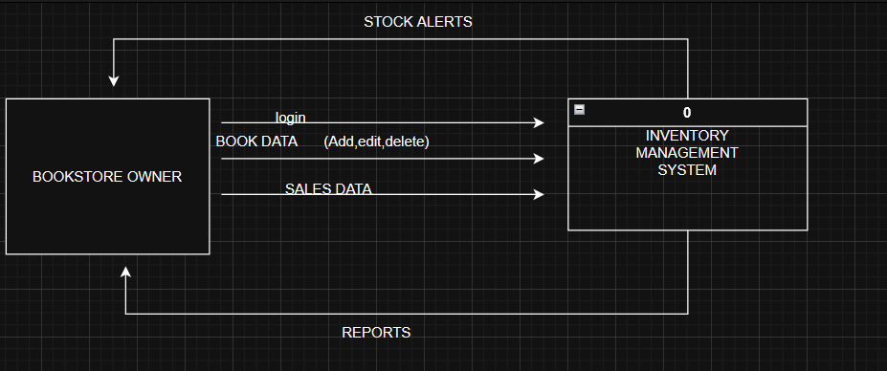
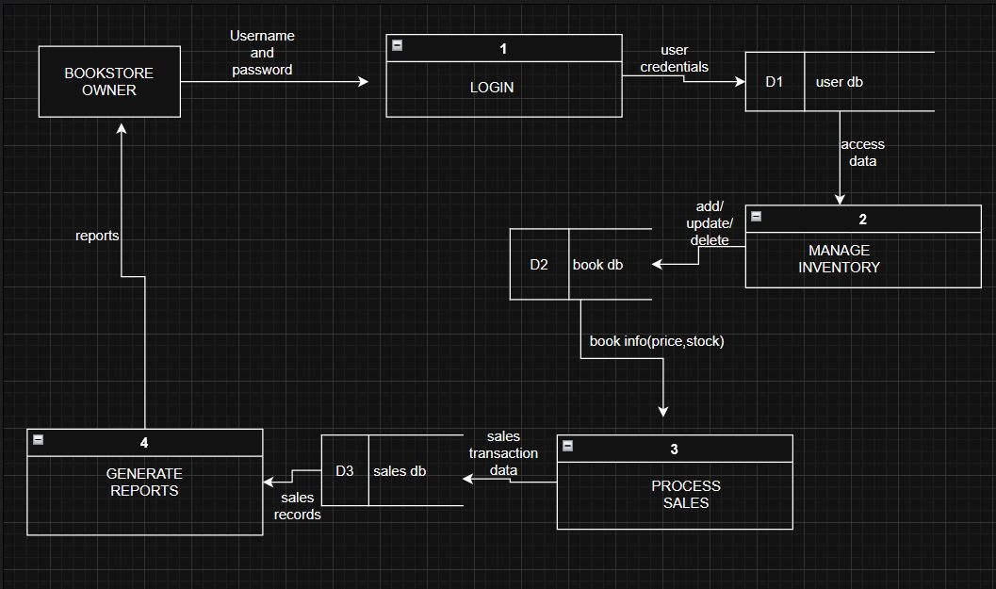
Figure 2.3.3 DFD

The Level 1 Data Flow Diagram illustrates how the bookstore inventory management system is divided into four main processes: login, inventory management, sales processing, and report generation. The bookstore owner interacts with the system by entering login details, managing book records, processing sales, and viewing reports. Each process communicates with specific data stores, namely the User Database, Books Database, and Sales Database, ensuring proper data storage, retrieval, and system functionality.

Entity relationship diagram
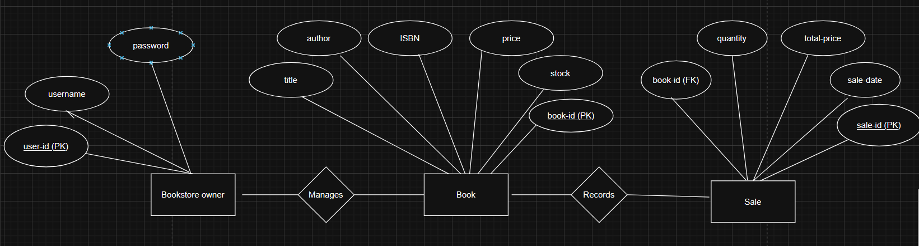
Figure 2.3.4 ER Diagram

The Entity Relationship Diagram (ERD) represents the database structure of the bookstore inventory management system. It consists of three main entities: User, Book, and Sale. The User entity stores login credentials for system access. The Book entity contains details about each book, including title, author, price, stock level. The Sale entity records transaction details such as quantity sold, total price, and sale date. The relationships show that one user can manage many books, while each book can be associated with multiple sales. The Sale entity includes a foreign key (book_id) to link each sale to a specific book, ensuring data integrity and proper tracking of transactions.

Use case diagram
The use case diagram for the Bookstore Inventory Management System illustrates the interactions between the bookstore owner and the system. The actor, represented by a stick figure, can perform several functions within the system boundary, including login, managing books (adding, editing, deleting), viewing inventory, selling books, viewing sales logs, generating reports, and searching books. Each functionality is represented as an oval, and lines connecting the actor to the use cases show the interactions. This diagram helps visualize the system’s main features and the user’s role in performing tasks efficiently.

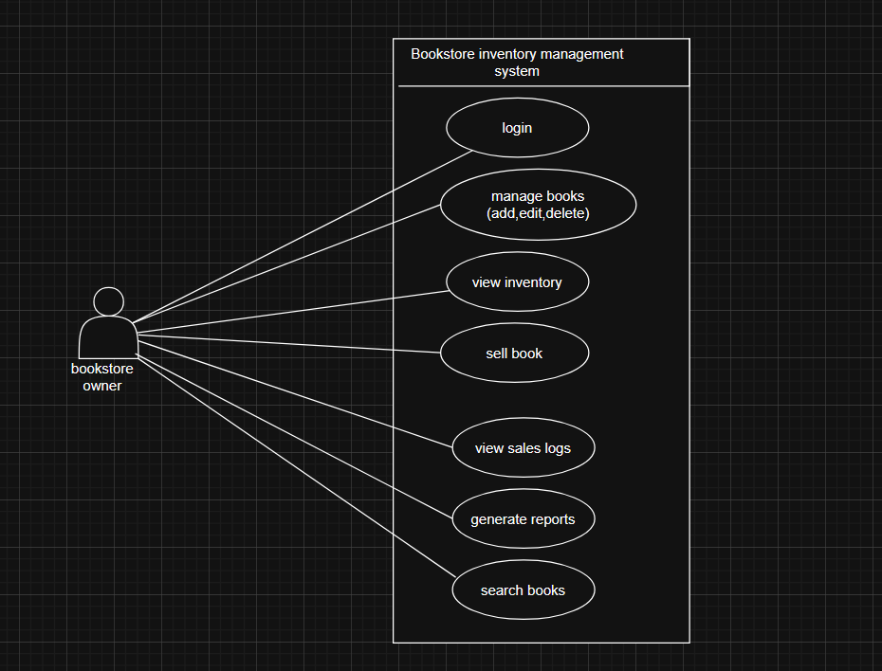
Figure 2.3.5 use case diagram

Class diagrams
The class diagram for the Bookstore Inventory Management System shows the main classes in the system and how they relate to each other. The User class represents the bookstore owner who can log in and manage operations. The Book class stores details about each book, such as title, author, price, and stock. The Sale class records transaction information, including the date and total amount, and is linked to both the user and the books sold. The Report class generates reports based on sales data. The relationships between these classes illustrate how users create sales, sales contain books, and reports are generated from sales, providing a clear structure of how the system functions.

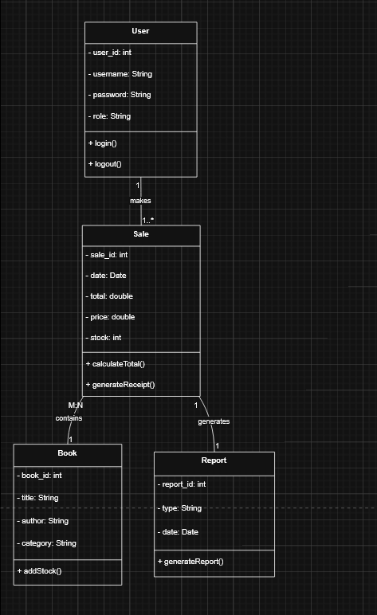
Figure 2.3.6 class diagram

CHAPTER THREE: SYSTEM IMPLEMENTATION

Introduction
This chapter focuses on the implementation of the system, detailing the journey from development to deployment. It begins with the development process, explaining how the design specifications and requirements were transformed into a working application using suitable programming tools, frameworks, and technologies. The chapter then discusses the testing phase, highlighting the methods employed to identify and correct errors, ensure system reliability, and confirm that all functionalities meet user requirements. Finally, it covers the deployment process, describing how the system was prepared for actual use, including installation, configuration, and user accessibility considerations. Throughout the chapter, challenges encountered during each stage are explained along with the solutions applied, providing insight into the practical aspects of system implementation

User Interface Development

Login Page Development
The login form allows users to securely access the bookstore Inventory Management System by entering a valid username and password. It captures input data, validates user credentials, and authenticates access. Upon successful login, users are granted entry to the system, while incorrect details prompt error messages, ensuring secure and controlled system access.
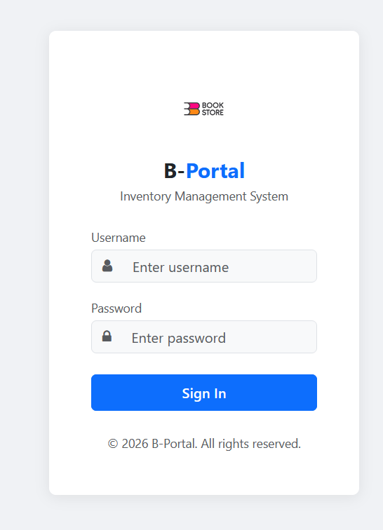

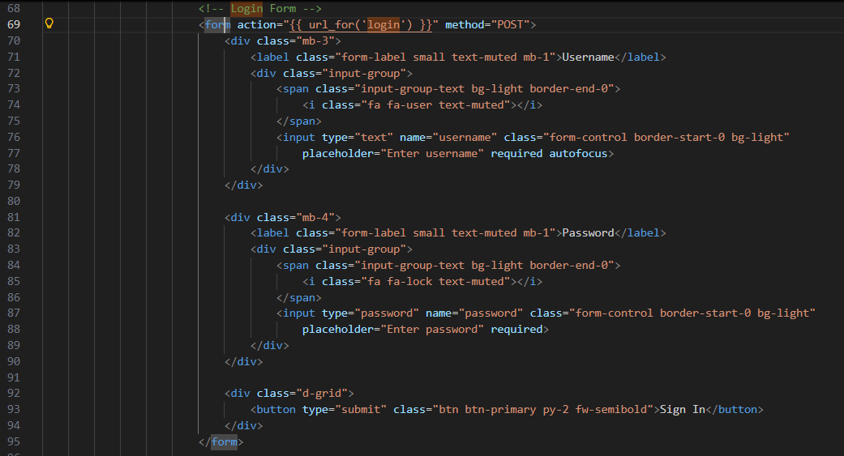
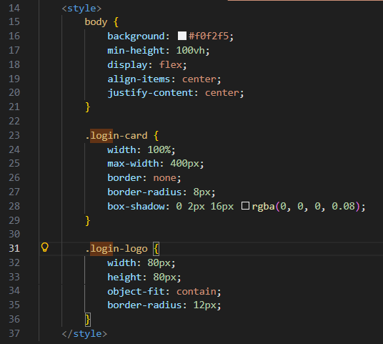
Figure 3.2.1 login page development

Dashboard
This dashboard provides a clear overview of inventory performance, showing total stock, low stock alerts, and daily revenue. It also highlights recent additions and offers quick navigation, making inventory tracking and management efficient and user-friendly.
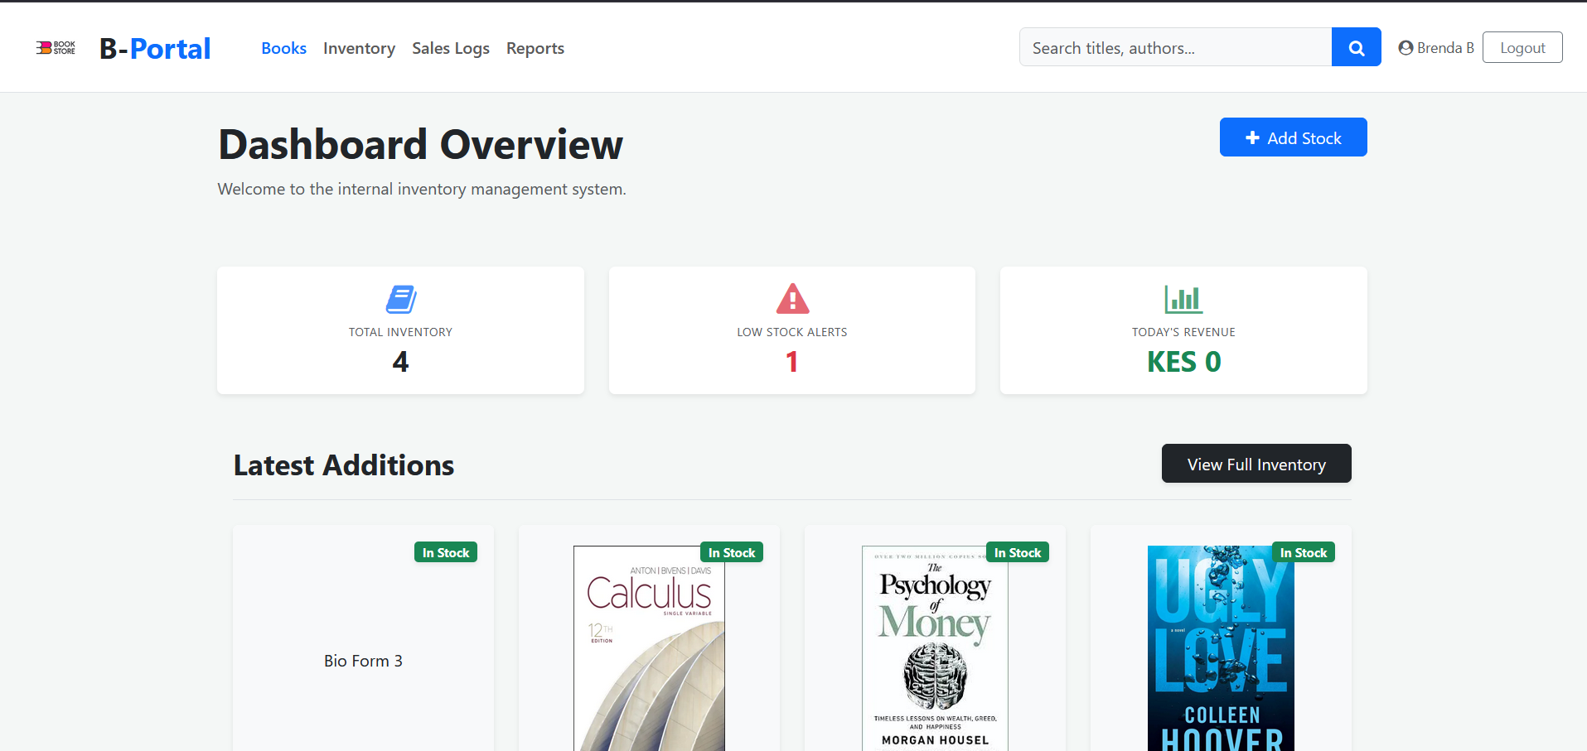

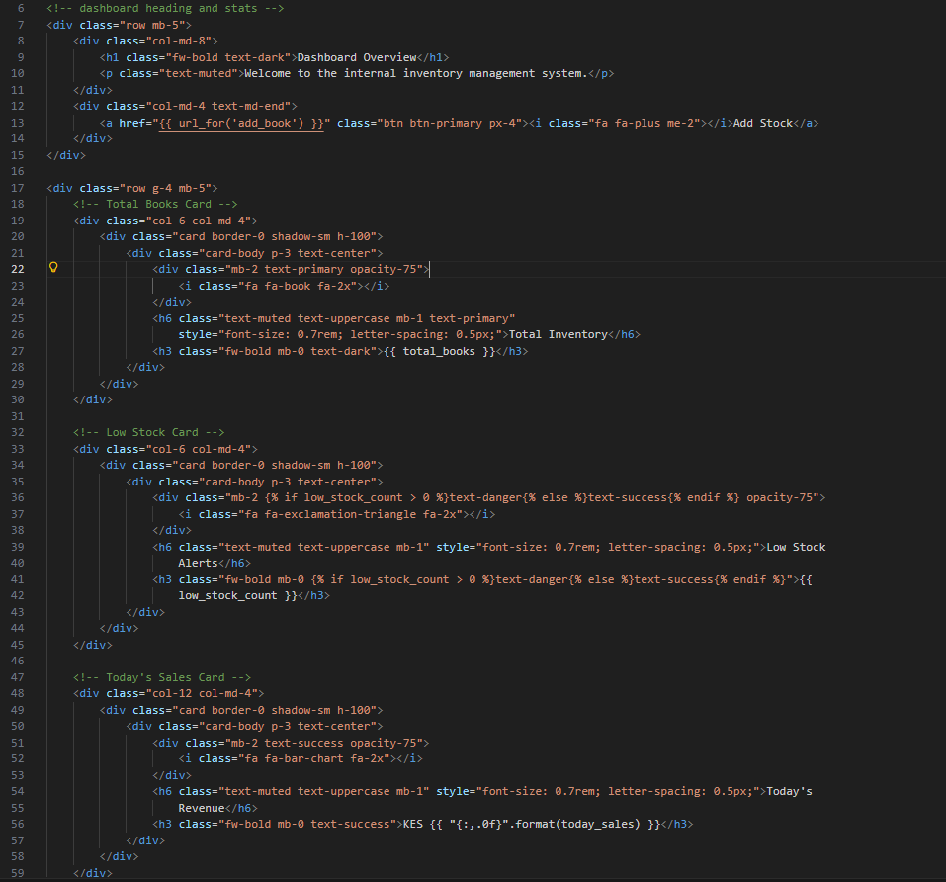
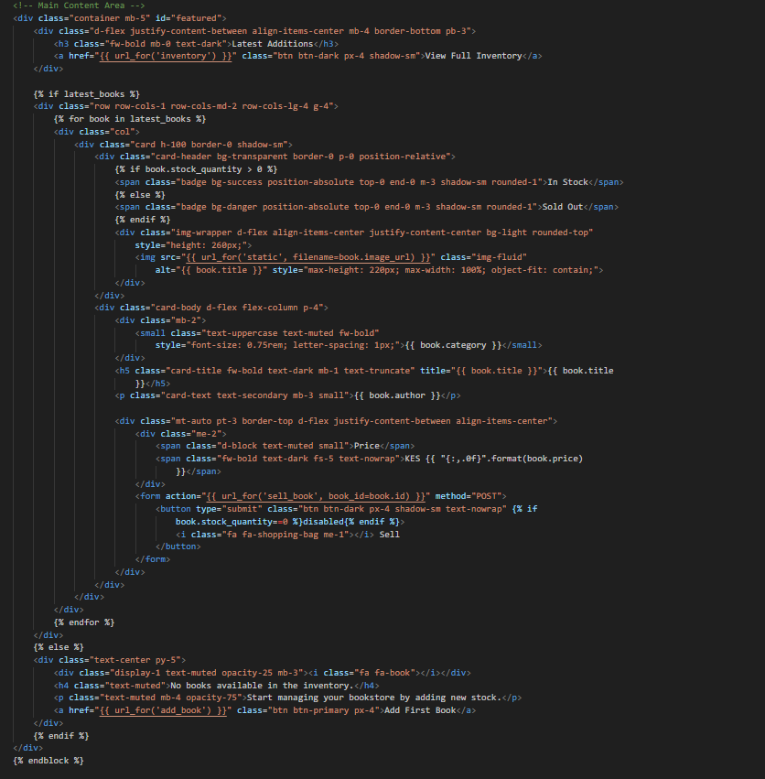
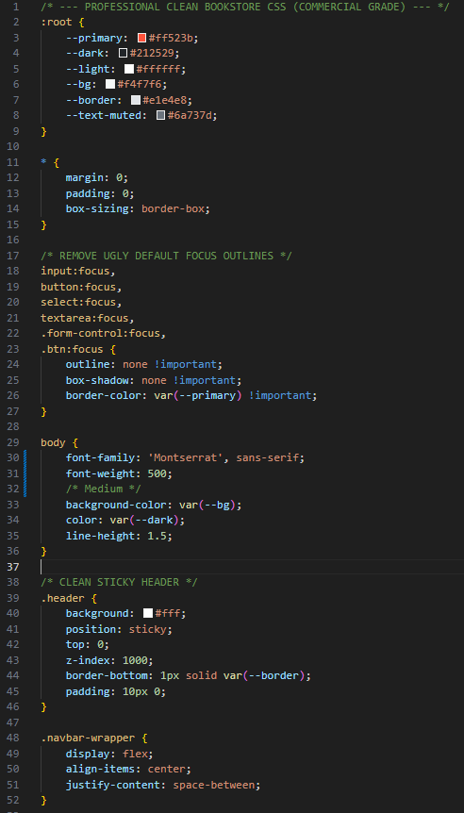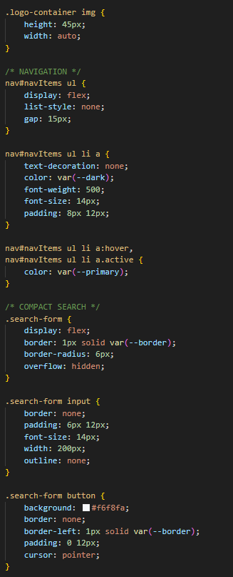
Figure 3.2.2 dashboard development

Navigation bar
This navigation bar provides quick access to key sections like Books, Inventory, Sales Logs, and Reports. It also includes a search function and user profile controls, ensuring easy navigation and efficient system interaction.

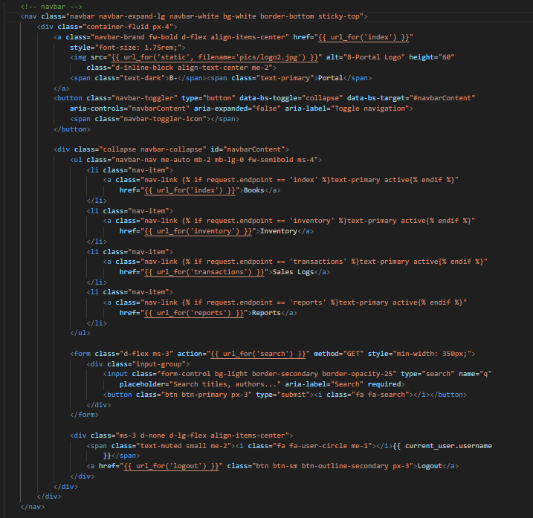
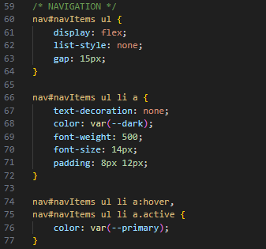
Figure 3.2.3 navigation bar

Inventory
This inventory control center displays detailed book information including price, stock levels, and categories. It allows quick actions like selling, editing, or deleting items, while highlighting low stock alerts to help maintain efficient inventory management.
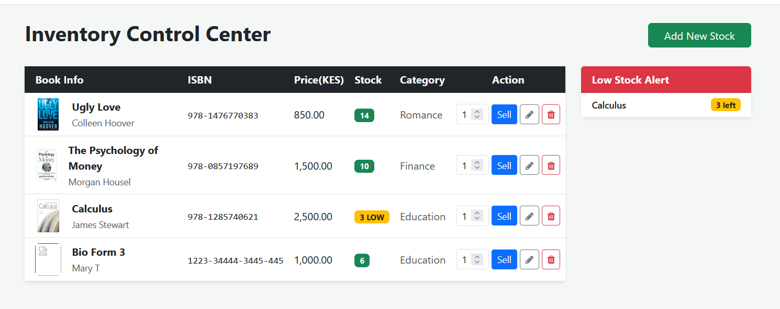
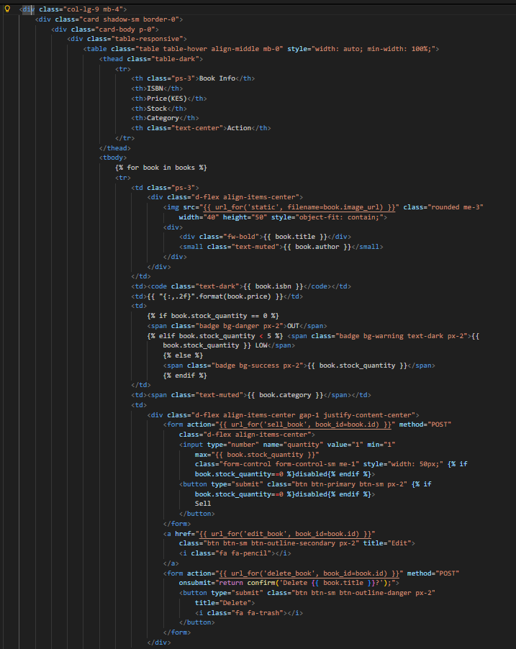
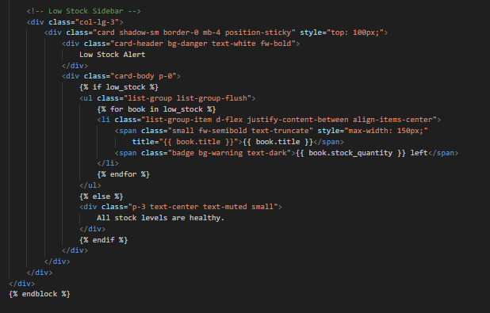
Figure 3.2.4 inventory control center

Add new book form
The Add New Book form is a data-entry interface designed for adding new titles to the inventory database. It uses a clean, grid-based layout to ensure all required metadata is captured quickly.
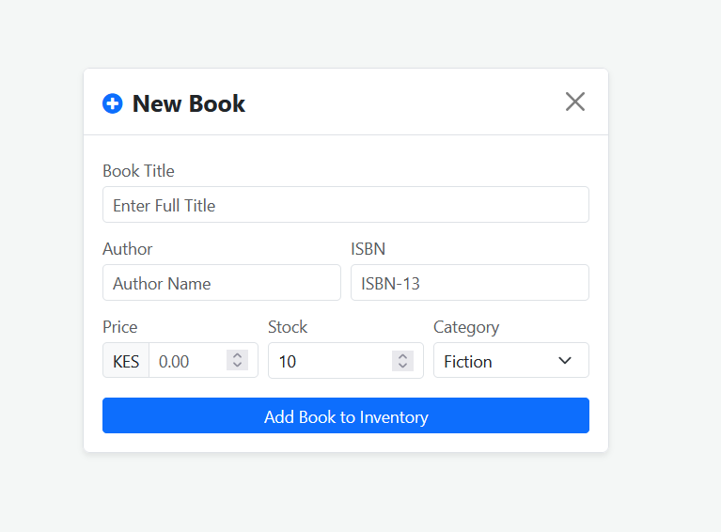
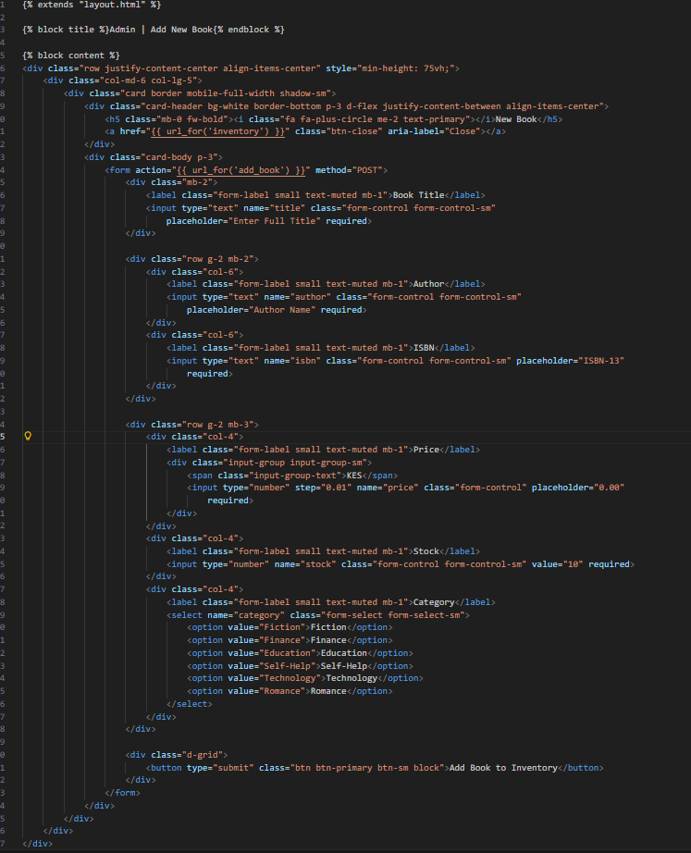
Figure 3.2.5 add new book

Sales logs
The Real-Time Transaction Logs section provides an automated audit trail of all sales and inventory changes. It is designed to give administrators an immediate, high-level view of daily operations without needing to generate manual reports.
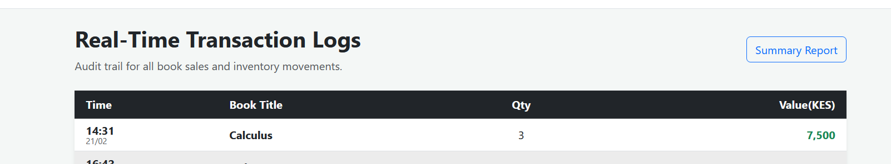
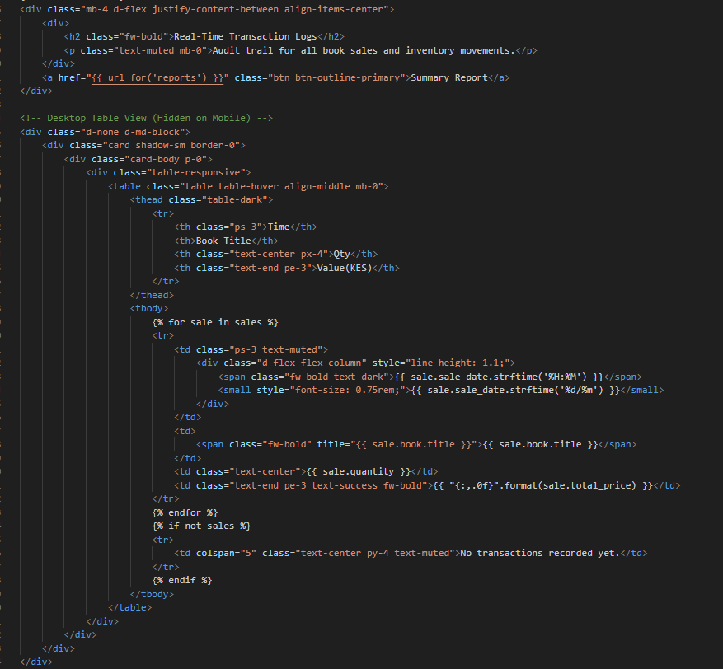
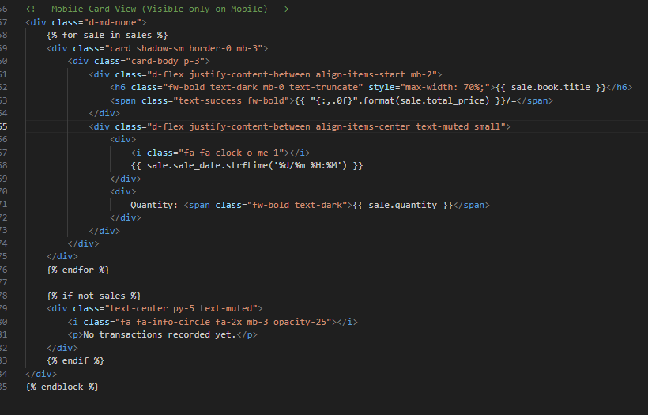
Figure 3.2.6 sales logs

Reports
The Reports Center provides a comprehensive summary of business performance, including sales trends, revenue analysis, and inventory movement. It helps users generate insights, track progress over time, and make informed decisions through organized and easy-to-read reports.

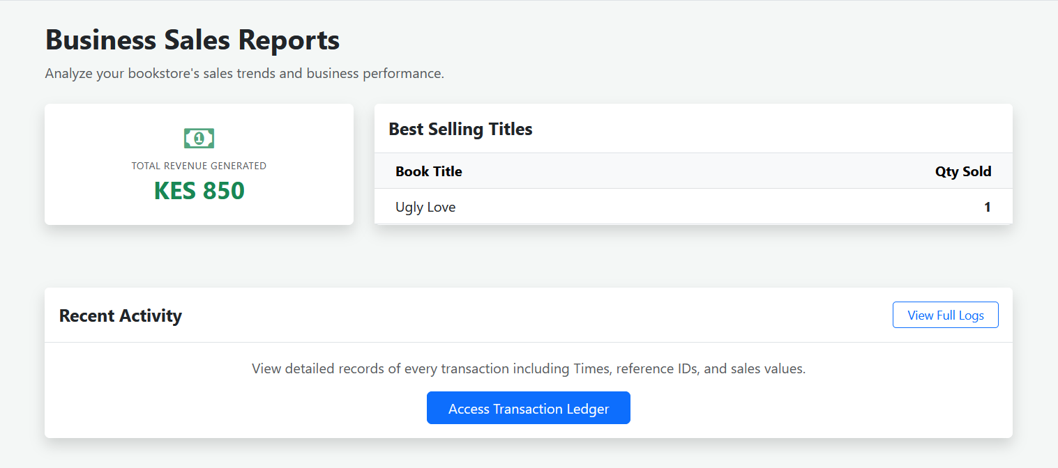

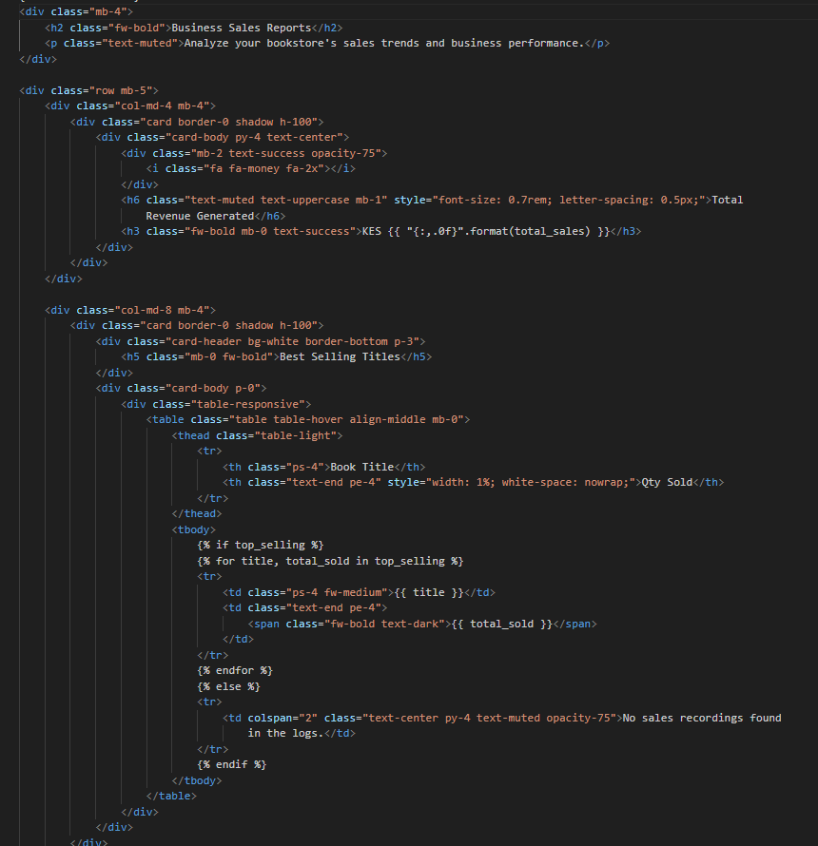
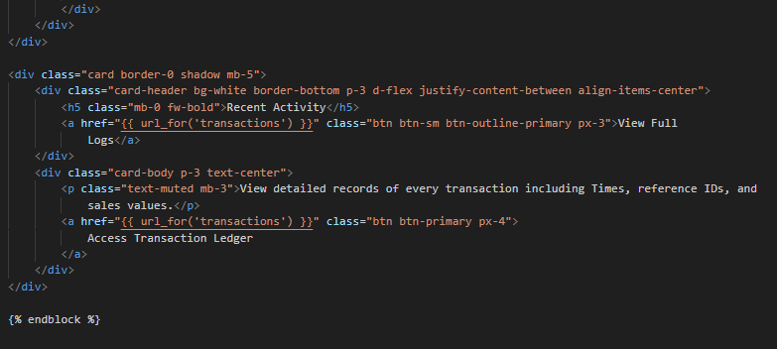
Figure 3.2.7 reports

Logic Development

Login
The login process uses a standard Flask-Login workflow. It first checks if a user is already authenticated; if so, it redirects them to the dashboard. For new login attempts, the system extracts the username and password from a POST request, searches the database for a matching user, and verifies the password hash. If the credentials are valid, it initializes a session via login user and redirects the user to their intended destination. If authentication fails, it triggers a "danger" flash message and reloads the login template.
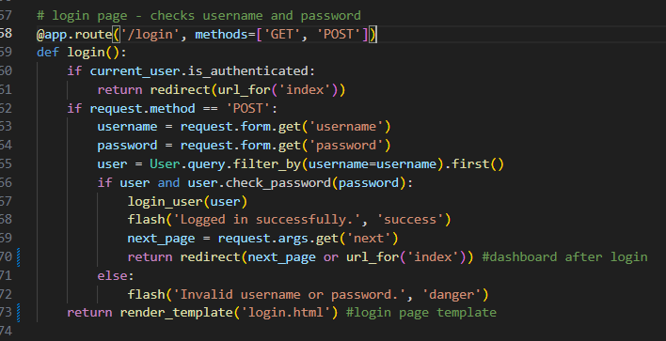
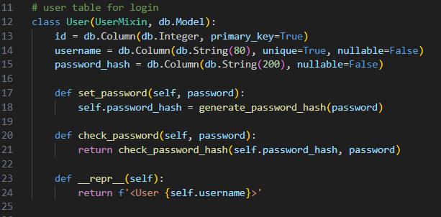
Figure 3.3.1 Python-based user authentication function implemented using the Flask framework

Dashboard
The /logout route requires the user to be logged in, logs them out using logout user (), shows a success message with flash (), and then redirects them to the login page. The / (dashboard) route also requires login and displays summary statistics: it counts the total number of books, counts books with low stock (less than 5 items), calculates today’s total sales using a database aggregate function (sum of Sale. total price filtered by today’s date), retrieves the 8 most recently added books, and passes all this data to the index.html template for rendering.
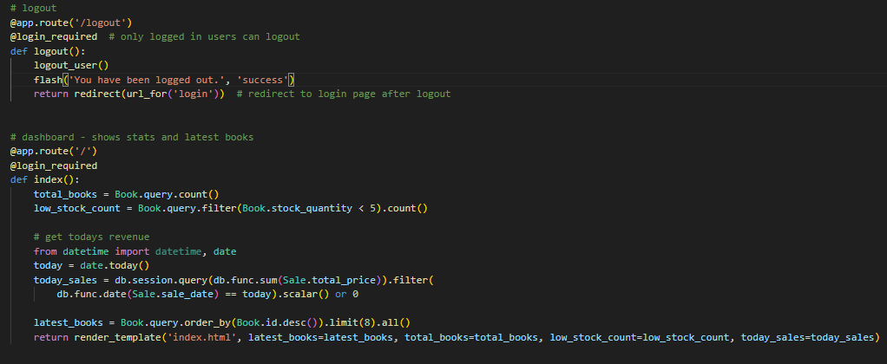
Figure 3.3.2 dashboard backend development

Inventory
The /inventory route displays all books and highlights low-stock items. The /add_book route (GET/POST) allows logged-in users to create a new book by submitting a form, saving it to the database, and redirecting to the inventory page with a success message. The /edit_book/<id> route lets users update an existing book’s details, pre-filling the form and saving changes to the database. The /delete_book/<id> route deletes a book (and its related sales records first) from the database. The /sell_book/<id> route reduces stock when a sale is made, records the sale with total price, and prevents selling if stock is insufficient. Finally, the /search route allows users to search books by title, author, or ISBN using a case-insensitive query and displays the matching results.

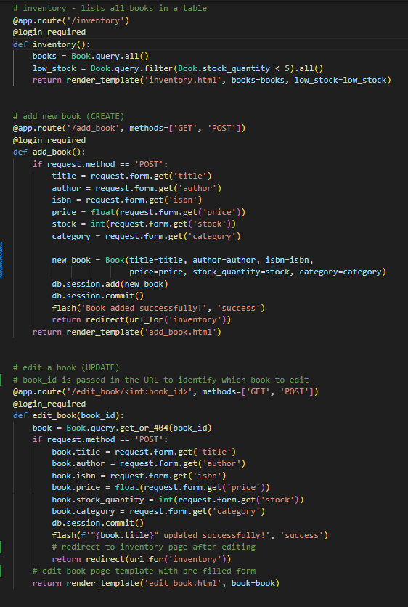

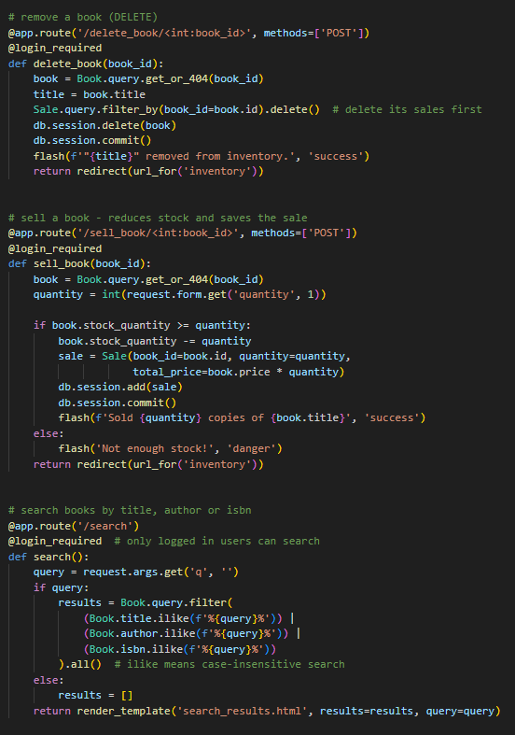
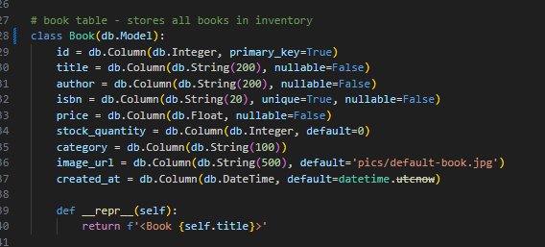
Figure 3.3.3 inventory backend development

Sales logs and reports
This Flask code defines two authenticated routes in a web app. The /transactions route retrieves all sales records from the database, ordered by sale_date in descending order, and passes them to the transactions.html template for display. The /reports route generates summary data: it calculates the total revenue by summing Sale.total_price, and finds the top 5 best-selling books by summing Sale.quantity per book, grouping by Book.id, ordering by total sold in descending order. These results are then rendered in the reports.html template.
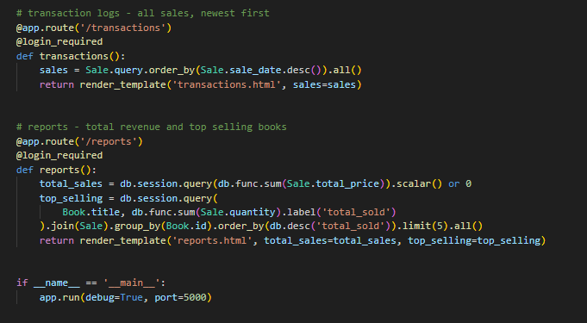
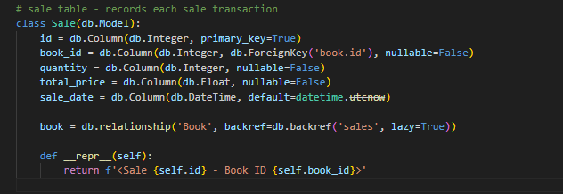
Figure 3.3.4 sales backend development

Testing
- User Login Feature
Testing Action: I attempted to log in using both valid and invalid credentials to verify whether access was granted correctly and error messages were displayed.
Result: The system allowed correct login but initially did not show an error for incorrect credentials.
Correction: I updated the login validation code to display an appropriate error message when credentials are invalid.
- Inventory Entry Form
Testing Action: I added sample products to the inventory to check if the details were correctly saved to the database.
Result: Correctly saved.
- Sales Log Recording
Testing Action: I recorded sample sales transactions to verify that the system updated inventory quantities and calculated totals correctly.
Result: The system initially did not reduce inventory stock after a sale.
Correction: I fixed the stock update logic so that inventory automatically decreases when a sale is recorded.
- Report Generation
Testing Action: I generated inventory and sales reports for different dates to check the accuracy of totals and summaries.
Result: Some entries were missing due to incorrect date filtering.
Correction: I corrected the filtering logic, and all relevant data now appears in the reports.
- System Navigation and Buttons
Testing Action: I navigated through all menus and clicked buttons to verify that each directed to the correct page or performed the intended action.
Result: Worked perfectly.

Deployment
The Bookstore Inventory System has been successfully deployed on PythonAnywhere, providing a reliable and accessible web-based platform for managing inventory. PythonAnywhere offers a cloud-hosted Python environment, which ensures the application runs continuously without local server dependency. The deployment process involved uploading the project files, configuring the virtual environment with required packages, and setting up the web app with the correct WSGI configuration. This deployment enables users to access the system from any device with internet connectivity, ensuring real-time inventory tracking, seamless data management, and efficient operational workflows, all hosted securely in the cloud.
Access the live system here: Bookstore Inventory System

CHAPTER FOUR: CONCLUSION AND RECOMMENDATION

Conclusion
The aim of this project was to develop a Bookstore Inventory Management System that improves the efficiency of managing bookstore operations. Chapter One discussed the problem statement, justification of the study, and the objectives of the system. It highlighted the challenges faced by bookstores that rely on manual record keeping such as stock inaccuracies and difficulty in tracking sales. Chapter Two focused on the design and modelling of the system using diagrams such as the Data Flow Diagram, Entity Relationship Diagram, Use Case Diagram, and Class Diagram to illustrate how the system operates. Chapter Three described the implementation of the system including the development of the user interface, logic implementation using the Flask framework, system testing, and deployment.
The developed system successfully automates important bookstore operations including inventory management, sales logging, and report generation. The system helps the bookstore owner track stock levels, record transactions, and generate reports for better decision making. During the development of this project, I gained new knowledge in web development using Flask, database management using SQLite, and system deployment using cloud hosting platforms. However, some challenges were encountered such as debugging code errors and ensuring proper integration between the front-end and back-end components. These challenges helped improve my problem-solving and programming skills.

Recommendation
Although the Bookstore Inventory Management System functions effectively, there are several improvements that future developers can implement to enhance its capabilities. One improvement would be integrating mobile payment services such as M-Pesa or bank card payment systems so that customers can pay electronically instead of relying only on manual sales entry.
Another improvement would be the integration of barcode scanning technology. This would allow books to be scanned quickly during sales instead of manually searching for them in the system, thereby improving efficiency and reducing human error.
Future developers may also consider upgrading the system database from SQLite to a more scalable database such as MySQL or PostgreSQL to support larger amounts of data and multiple users. Additionally, the system can be enhanced by implementing advanced analytics and graphical reports that provide deeper insights into sales trends and inventory performance.

REFERENCES

Djohan, T., & Stefvy. (2023, April). “Inventory Shortages and Poor Management Systems Negatively Affect Customer Satisfaction in the Bookstore Industry”. Research Synergy Press Journals.https://www.researchgate.net/publication/371763839_The_Impact_of_Inventory_Managementon_Customer_Satisfaction_at_Apotik_Global_Medan
International Telecommunication Union (ITU). (2023). Measuring digital development: Facts and figures 2023. https://www.itu.int/en/Pages/default.aspx
Laudon, K. C., & Laudon, J. P. (2022). Management information systems: Managing the digital firm (17th ed.). Pearson Education.
Mhlongo, N. et al (2024, February 6). “Reviewing the impact of cloud computing on small and medium enterprises in Africa”. International journal of science and research Archive. https://ijsra.net/sites/default/files/IJSRA-2024-0236.pdf?utm
Rashid et al. (2025, July 18) “A Review of Technological Advancements and Operational Improvements in IoT for Retail Inventory Management”. IJRISS https://rsisinternational.org/journals/ijriss/articles/a-review-of-technological-advancements-and-operational-improvements-in-iot-for-retail-inventory-management/

